EMPLOYEE EXPENSE TRACKING SYSTEM

USER MANUAL

TWIN-CIRCA MARKETING

ESPOSADO VILLAGE, CANNERY SITE

POLOMOLOK, SOUTH COTABATO 9504

**USER MANUAL VERSION: 1.0**

**MARCH 2021**

Table of Contents

Introduction 1

General Information 1

System Overview 1

Common Features 1

System Requirements 2

Hardware Requirements 2

Software Requirements 2

Getting Started 3

Starting the Web Application 3

Navigating the Web Application 3

Application Bar 3

Navigation Drawer 3

Footer 3

Working with Data Tables 3

Filtering data table 4

Sorting data table 4

Refreshing data table 4

Showing additional row data 4

Selecting rows 4

Perform actions on selected rows 4

Pagination 5

Access, Authentication, and Authorization 5

Signing in to the application 5

Roles and Permissions 5

Application Modules 6

Dashboard 6

Profile 7

Updating information 7

Change password 7

Expense 8

Creating new expense 8

Editing expenses 8

Cancelling and restoring expenses 8

Expense Report 9

Creating new expense report 9

Editing expense report 9

Submitting expense report 9

Printing expense report 9

Approval and rejection of expense reports 9

Cancelling expense reports 9

Payment 10

Creating new payment record 10

Confirming payment 10

Cancelling payment record 10

Employee 11

Creating new employee 11

Editing employee information 11

Resetting employee password 11

Editing Revolving Fund 11

Editing Permissions 11

Deactivating and activating employee 11

Deleting employee 11

Vendor 12

Creating new vendor 12

Editing vendor information 12

Deactivating and activating vendor 12

Deleting vendor 12

Department 13

Creating new department 13

Editing department 13

Deleting department 13

Job Designation 14

Creating new job designation 14

Editing job designation 14

Deleting job designation 14

Expense Type 15

Creating new expense type 15

Editing expense type 15

Deleting expense type 15

Activity Logs 16

Notifications 17

Settings 18

Appendices 20

Definition of Terms 20

Figures 21

Troubleshooting 22

Software Troubleshooting 22

Network Troubleshooting 22

Important Notes 22

# Introduction

## General Information

This user manual has been created to outline the overall setup and system functionalities. This includes the system requirements, proper setup and configuration, tutorials for application modules, and other system considerations and specifications. This document also provides an overview of the system to depict different aspects of the system and functions as a reference for system users.

## System Overview

The Employee Expense Tracking System is a web-based application that manages travel-related expenses of employees. It allows users to record, submit, track, process, and reimburse employee expenses. The system used to improve and streamline current process, data management and increase response time.

## Common Features

*Record Keeping*

The application is used in storing data to keep accurate records. Usual data that comprise overall transaction include employee information, vendors, expenses, and payment records.

*Status Monitoring*

The application is used for monitoring status of records mainly on expense reports submission and approval to avoid delays on employee reimbursement.

*Reporting*

The Employee Expense Tracking System provides an accurate data visualization for reporting and analysis. The system can generate summary of expense reports as well as overall expenses of the company.

## System Requirements

The minimum requirements for running the application required to operate the Employee Expense Tracking System are listed below:

### Hardware Requirements

* 1 x LCD/LED Monitor
* 1 x Computer Mouse
* 1 x Keyboard
* 1 x System Unit
  + 1 x VGA port
  + 2 x USB port
  + 1 x Ethernet port
  + RAM: 1 GB (32-bit) or 2 GB (64-bit systems); Recommended 4 GB or above
  + CPU: 1 GHz or higher
  + Hard disk space: 16 GB (32-bit) or 20 GB (64-bit systems); Recommended 64 GB or above
* 1 x Inkjet Printer (300*300 DPI)
* Ethernet connection (LAN) or a wireless adapter (Wi-Fi)

### Software Requirements

* Operating System (Recommended: Latest version)

Supported operating systems include:

* + Microsoft Windows 7 / 8 / 10
  + MAC OS X 10.4 or later
  + Linux v.20 or later
* Web Browser (Recommended: Latest version)

Supported web browsers include:

* + Google Chrome v.58 +
  + Mozilla Firefox v.54 +
  + Microsoft Edge v.14 +
  + Safari v.10 +

# Getting Started

## Starting the Web Application

To access the application, open a web browser in your computer and then type in the link *http://192.168.1.99:82/* in the browser’s address bar. In the application, login page will be loaded first, enter the username and password and click the Login button. The username and password are verified and cached on the Web application server for the remainder of the session. After a successful login, you will be redirected to the dashboard of the application.

## Navigating the Web Application

### Application Bar

The application bar is the primary source of site navigation found on topmost section of every page. This consists of a navigation drawer menu, the home menu (labeled as the application’s name), notifications menu, and logout menu.



Figure Application Bar

### Navigation Drawer

The navigation drawer is what the users will utilize to navigate through the application. This is primarily used to house links to the pages and found on the rightmost section of the application.

*Figure #. Navigation Drawer*

### Footer

The footer is the section of content at the very bottom of the application that provides additional information. It contains a copyright notice and the company name.

*Figure #. Footer*

## Working with Data Tables

The data tables display a list of information consists of retrieved records from the database depending on the application’s modules.

### Filtering data table

The most basic functionality for filtering results is the search using the search bar found on top of every table list. This returns a list of matched records based on the typed characters in the text field.

Other filter options can be found on top of the search bar of every table list. Some filter options include status (mainly on expenses, reports, and payments including activation status of employees and vendors), selectors for employees, vendors, departments, and job designations.

### Sorting data table

Sorting table data can be done by clicking the column header in the table.

### Refreshing data table

To refresh the records, click the refresh button found on top of the search bar.

### Showing additional row data

By clicking the dropdown button found on the rightmost part of every row in the table provides more information of a certain row in the table.

### Selecting rows

To select a certain row, click the checkbox found on leftmost part of every row in the table. The table can handle multiple selection and perform specific actions at once. To select all records, click the first column header with the checkbox and vice-versa.

### Perform actions on selected rows

Common action buttons such as show and edit buttons can be found on the right part of every row in the table.

To perform special actions, the buttons can be found on top of the table/search bar after selecting record/s in the table.

### Pagination

Pagination provides a way of separating long sets of data so that it is easier for the user to consume information. This can be found at the bottom of the table. This also consists of a dropdown option for providing how many rows can be displayed on every page.

## Access, Authentication, and Authorization

### Signing in to the application

In the login page of the application, type in the username and password and click the Login button. Then you will be redirected to the application’s dashboard after a successful login.

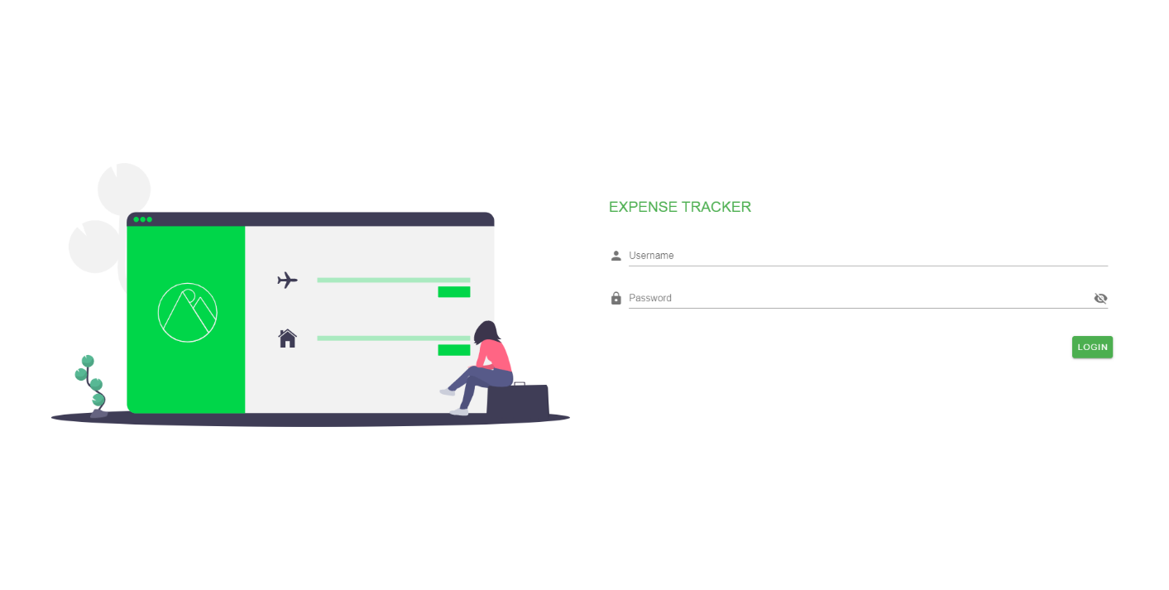

### Roles and Permissions

# Application Modules

## Dashboard

This module provides graphical representation for data visualization represented by charts and graphs. It consists views of key performance indicators and other information relevant to the company’s employee expense management.

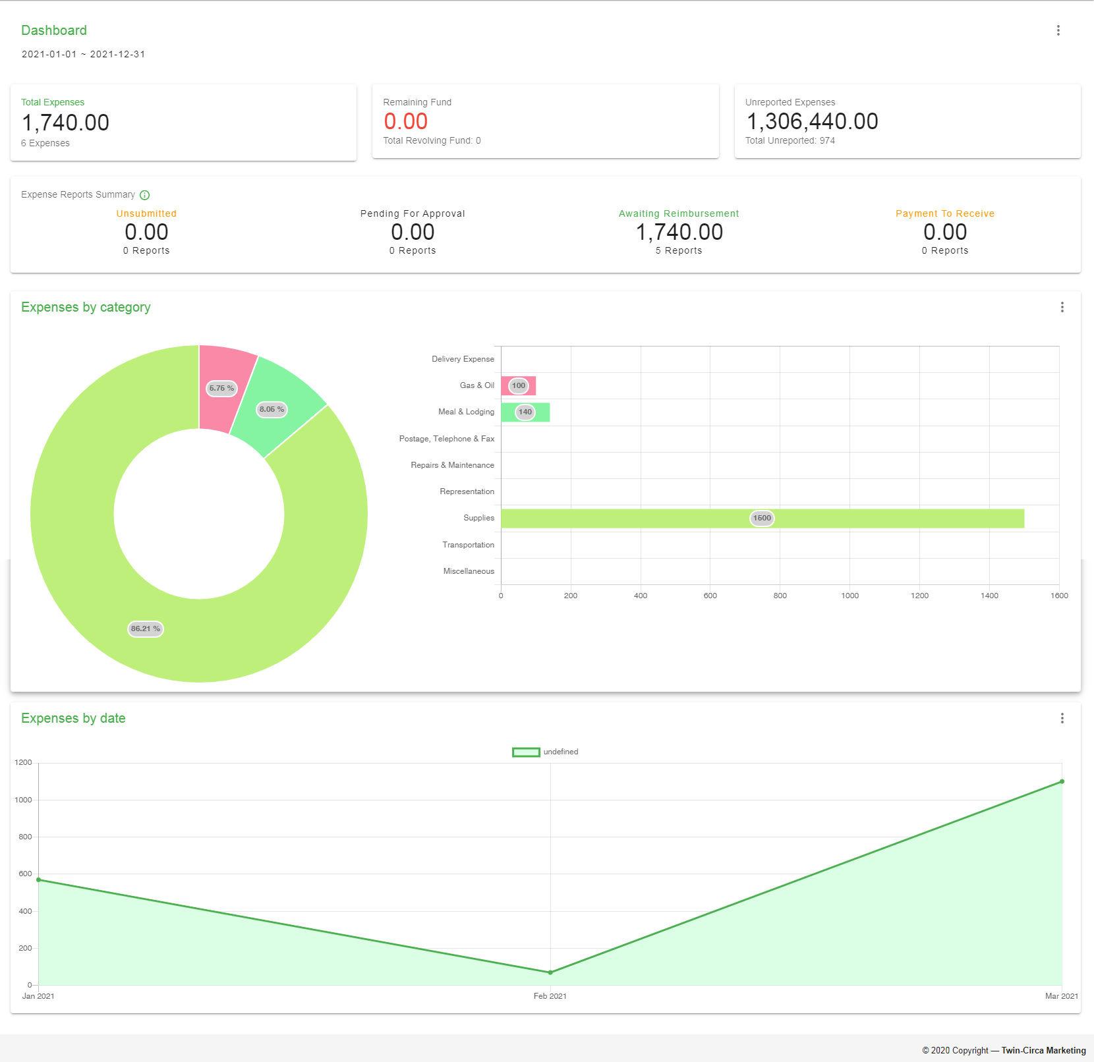

## Profile

This module is a record of personal, user-specific data associated with the user's identity. This also includes settings for updating personal and account information.

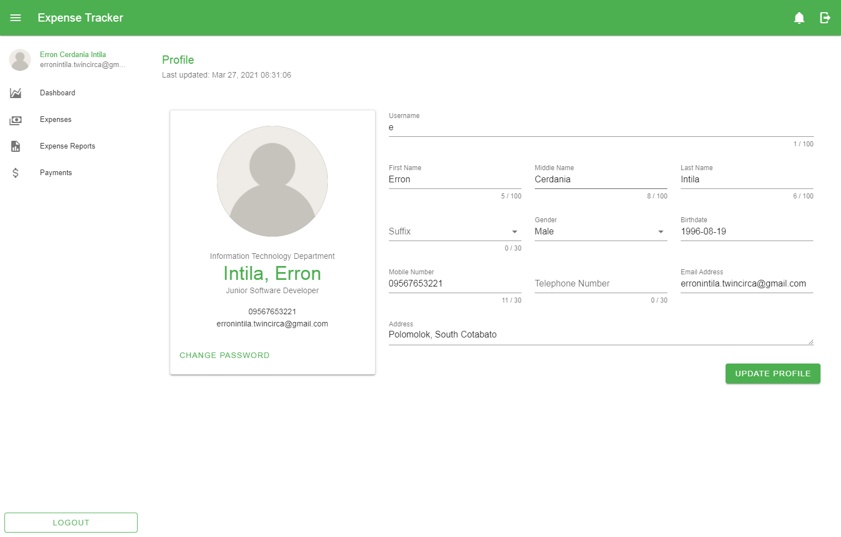

### Updating information

### Change password

Forgot password? Request the admin for reset

## Expense

This module involves management of each employee expenses. This allows the user to view, add, edit, and cancel expenses depending on the user role and level of permissions given.

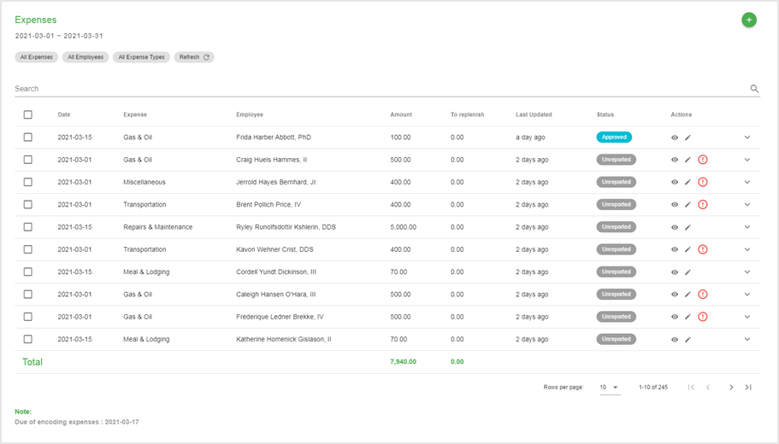

### Creating new expense

### Editing expenses

### Cancelling and restoring expenses

## Expense Report

This module allows the user to manage created expenses grouped into reports. This involves creation, submission, approval, rejection and cancellation of records. Each record has specific status used mainly for monitoring with regards to employee reimbursement.

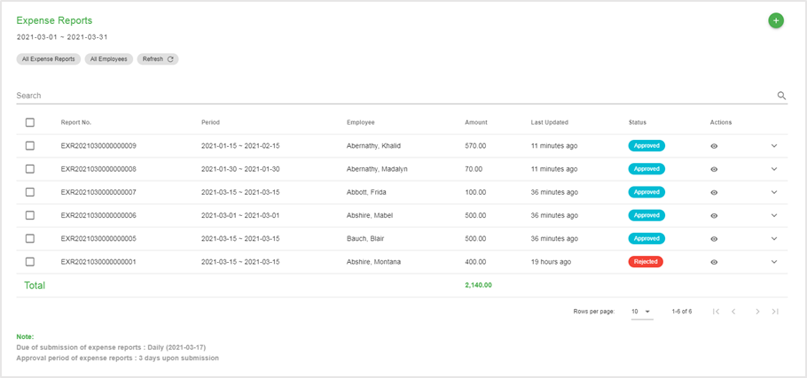

### Creating new expense report

### Editing expense report

### Submitting expense report

### Printing expense report

### Approval and rejection of expense reports

### Cancelling expense reports

## Payment

This module provides record of payments for approved expense reports. This also shows status of transaction whether a certain payment has been created or received by the employee.

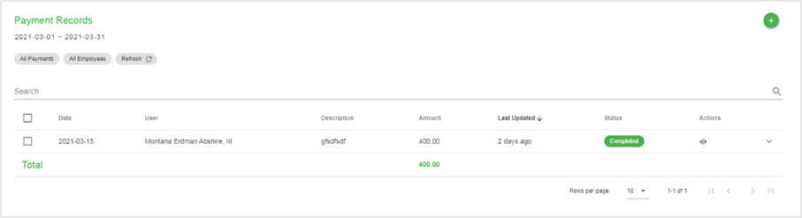

### Creating new payment record

### Confirming payment

### Cancelling payment record

## Employee

This module allows the user to manage employee records. Each employee record is considered a system user accompanied with specific roles and permissions.

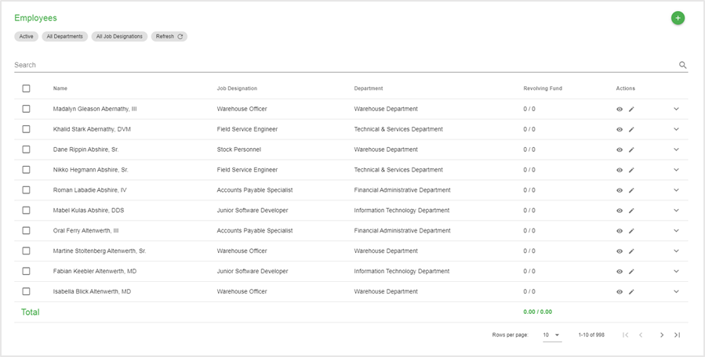

### Creating new employee

### Editing employee information

### Resetting employee password

### Editing Revolving Fund

### Editing Permissions

### Deactivating and activating employee

### Deleting employee

## Vendor

This module provides management of vendor records. This includes creating, updating, and setting activation for each record.

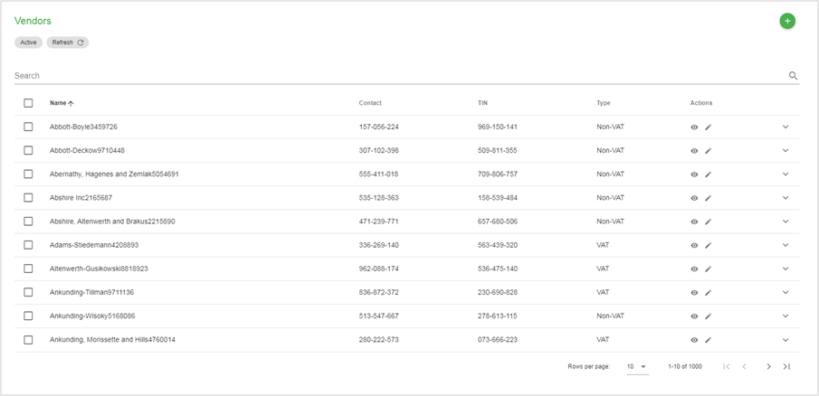

### Creating new vendor

### Editing vendor information

### Deactivating and activating vendor

### Deleting vendor

## Department

This module allows the user to create, edit, and delete department records used to classify each employee/system user.

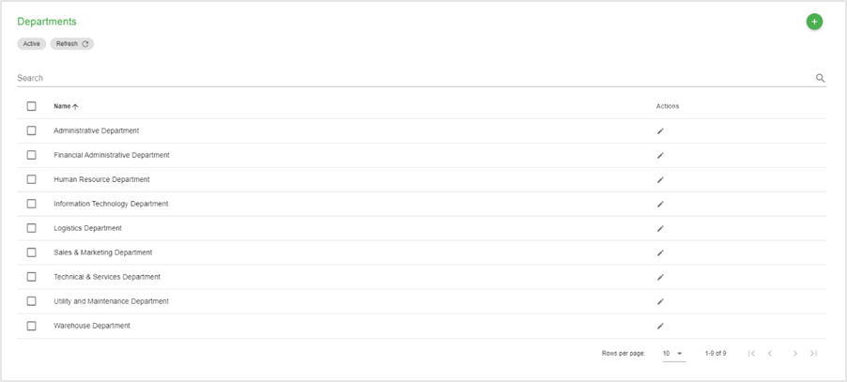

### Creating new department

### Editing department

### Deleting department

## Job Designation

This module provides information about job designation records that can be used upon creating of new employees. This module also allows the user to create, edit, and delete job designation records.

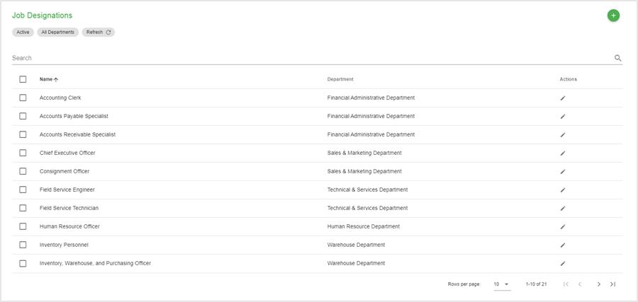

### Creating new job designation

### Editing job designation

### Deleting job designation

## Expense Type

This module allows the user to create, edit, and delete expense type records used mainly on creating of expenses to provide classification when generating reports.

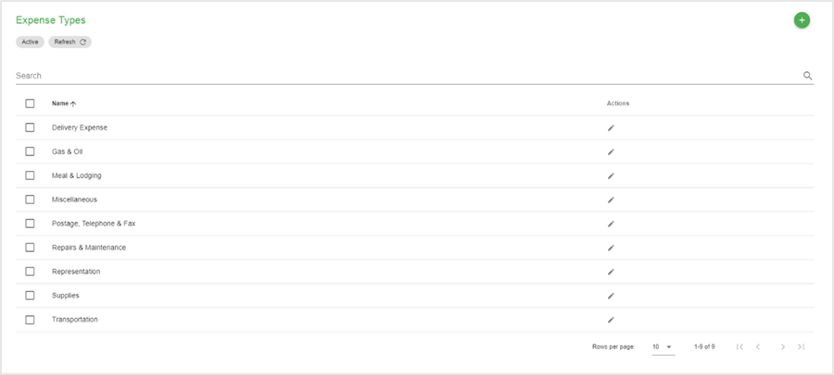

### Creating new expense type

### Editing expense type

### Deleting expense type

## Activity Logs

This module displays user activities within the application.

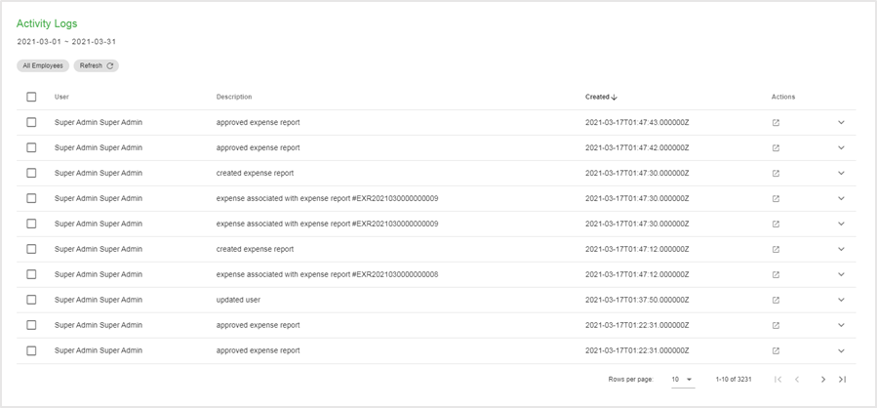

## Notifications

This module provides a message that appears on the right side of the application. This is a way to let the user know that something new has happened within the application (e.g. submitting expense report) to avoid missing transactions that might be worth the attention of the user and appears whether the user is using the application or not.

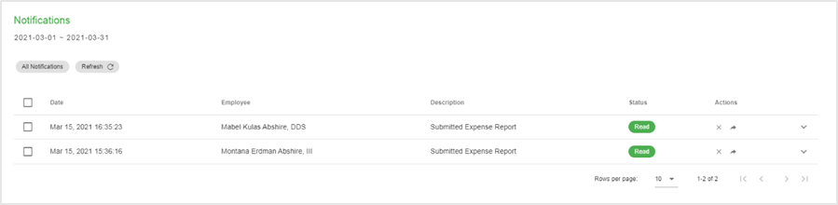

## Settings

This module provides access to the user to set up and maintain the application. This involves configuration on different modules when creating and updating records.

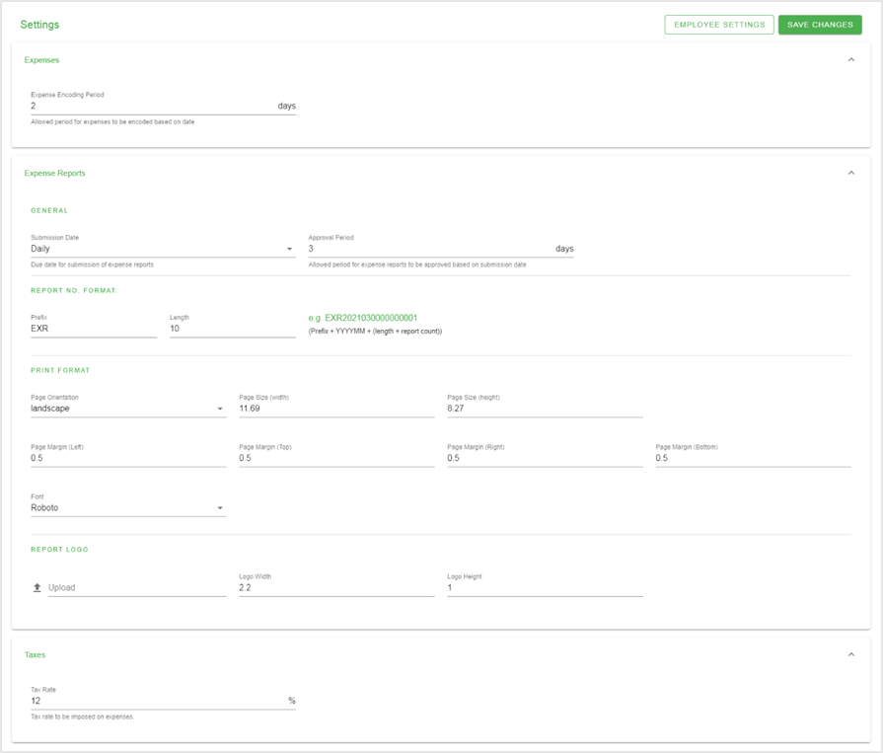

The settings are divided into following sections:

1. Expense Settings
   1. General
      1. Expense encoding period
2. Expense Report Settings
   1. General
      1. Submission date
      2. Approval period
   2. Report No. format
      1. Prefix
      2. Length
   3. Print format
      1. Page Orientation
      2. Page Sizes (height and width)
      3. Page Margins
      4. Font
   4. Report Logo
      1. Image
      2. Logo Sizes (height and width)
3. Tax Settings
   1. General
      1. Tax rate

# Appendices

## Definition of Terms

## Figures

Figure 1 Application Bar 3

## Troubleshooting

### Software Troubleshooting

### Network Troubleshooting

### Important Notes